ATTN: This is the Basic Requirements Document for the whole SSRS project. Each section in the SSRS curriculum will help you build a different part of this project. Refer to this document throughout the whole SSRS class and by the time the SSRS section is complete (6 classes) you should have completed this whole project.

Adventure Works Requirements

# Title: Sales Dashboard

# Document Participants and Approvals

Primary Author: Ali Muwwakkil

Contributors: Ali Muwwakkil

Reviewers: Anand Dasari

# Approvals

**The following have reviewed and/or approved this document:**

|  |  |  |  |
| --- | --- | --- | --- |
| Approver | Group | Date Submitted | Date Approved |
| Ali Muwwakkil |  |  |  |
| Anand Dasari |  |  |  |
|  |  |  |  |
|  |  |  |  |

# Revision History

This section records the change history of this document.

|  |  |  |  |
| --- | --- | --- | --- |
| **Name** | **Date** | **Reason For Changes** | **Version** |
| Ali Muwwakkil | 5-18-2012 | Original Draft | 1.0 |
|  | 5-19-2012 | Final changes approved | 2.0 |
|  | 12-20-2012 | Revision – added conditional formatting and cascading parameters | 3.0 |

Table of Contents

Title: Sales Dashboard 1

Document Participants and Approvals 1

Approvals 1

Revision History 1

Requirements 3

Novedea Adventure Works Sales Dashboard Overview 3

Adventure Works Sales Dashboard Report Navigation 3

Novedea Adventure Works Sales Dashboard filters 3

Filters 4

Sales by Year Chart 5

Sales Trend by Year / Month Chart 6

Sales by Territory Group Chart 7

Sales by Territory Chart 8

US Sales by State Chart 9

Top 10 Sales Reps Chart 10

Sales by Month Drilldown 11

Sales by Territory Drilldown 12

Sales by Rep Drilldown 13

# Requirements

## Novedea Adventure Works Sales Dashboard Overview

The Company is in need of a Sales Dashboard to track activity based on Year, Territory, Territory Group, State Sales and Top 10 Sales Reps.

The Dashboard will consist of 6 sections all tied to Sales throughout the company. Metrics provided will enable the company to have site into many different aspects of the business. We also want to start getting an idea of our trends by year.

## Adventure Works Sales Dashboard Report Navigation

#### Snapshot of Desired Dashboard Results

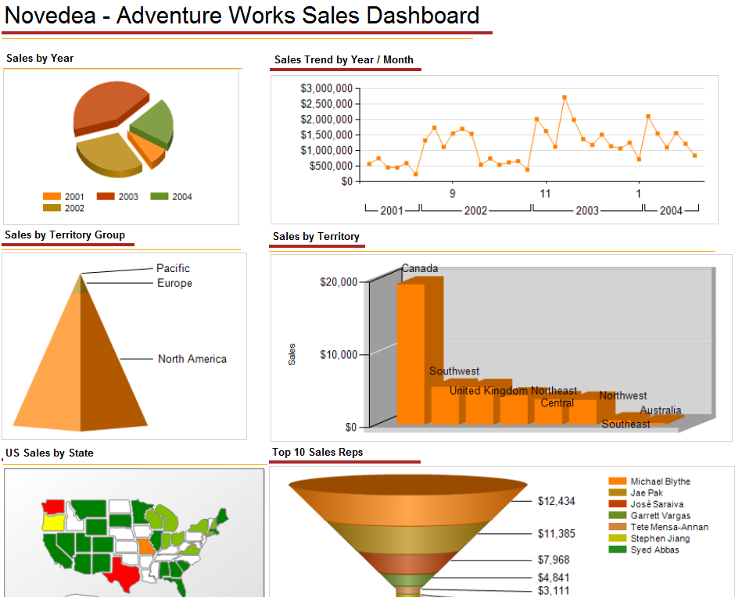

### 

### Novedea Adventure Works Sales Dashboard filters

#### Filters

* There shall be three filters at the top of the Sales Dashboard screen that will allow the user to see specific data.
* Those filters are as follows:
  + Year (Year of the OrderDate)
  + Territory Group (defined as Group within SalesTerritory table).
  + Territory (defined as Name within SalesTerritory table).
  + SalesRep (defined as First and Last Name of the SalesRep)
  + Job Title (defined as Job title of Sales Rep).
  + Ship State (defined Ship State of Order).
* These filters will display similar to the below example

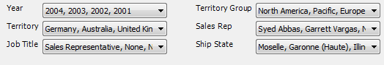

## Filters

| **Filter** | **Display Method** | **Table** | **Example** | **Notes** |
| --- | --- | --- | --- | --- |
| Year | Multi-Select List | SalesTerritory. OrderDate | 2004  2003  2002  2001 | Allow the user to select the year  Defaults to the all years |
| Territory Group | Multi-Select List | SalesTerritory. Group | All Territory Groups   * North America * Pacific * Europe | Allow the user to select the Group.  Defaults to the all Territory Groups |
| Territory | Multi-Select List | SalesTerritory.Name | * Germany * Australia * United Kingdom * … | Allow the user to select the Territory.  Defaults to the all Territory’s  Note: A Cascading Parameter should be set up on this parameter. Once the user selects 1 or multiple Territory Groups – this parameter should default to only Territory’s included in the Selected Territory Groups. |
| Sales Rep | Multi-Select List | Sales.vSalesPerson View | * Syed Abbas * Garrett Vargas * Shu Ito | Combine First Name and Last Name - Sales with no reps should be labeled “No Rep” |
| Job Title | Multi-Select List | Sales.vSalesPerson View | * Sales Representitive | Sales with no Sales Reps or Job Titles will be labeled “None” |
| Ship State | Multi-Select List | Combination of Person.StateProvince and Address | * Arizona * Texas * Florida |  |

### Sales by Year Chart

|  |  |  |
| --- | --- | --- |
| |  | | --- | | Sales by Year | | Indicates the Total Sales (Total Due) Grouped by Year. Legend at the bottom of the graph with a entry for every year in the database | |
| |  |  | | --- | --- | | Name: | Sales by Year Chart | | Type: | Pie Chart | | X Axis | N/A | | Y Axis | N/A | | Other: |  | | Tables: | Sales.SalesOrderHeader | | Drill-through Report: | Sales By Month Drilldown | | Notes: | Currency format will be comma separated with $ in front of all Revenue | |

.

### Sales Trend by Year / Month Chart

|  |  |  |
| --- | --- | --- |
| |  | | --- | | Sales Trend by Year / Month | | Indicates Total Sales (Total Due) graphed by Order Year ascending and Order Month desc. | |

|  |  |
| --- | --- |
| Name: | Sales by Year / Month |
| Type: | Line Chart |
| X Axis | Year , Month of Order Date |
| Y Axis | Total Sales (Total Due) |
| Other: | Graphs Total Sales by Month |
| Tables: | Sales.SalesOrderHeader |
| Drill-through Report: | N/A |
| Notes: | Y axis needs to display currency format |

|  |  |  |
| --- | --- | --- |
| Sales by Territory Group Chart    |  | | --- | | Sales by Territory Group | | Indicates a Visual of Total Sales (Total Due) by Territory Group. Smallest contributor should be displayed at the top of the pyramid. Table should be displayed below with Total Revenue grouped by Territory Group. Territory Name should be hidden until selects group to see Territory Details. | |

|  |  |
| --- | --- |
| Name: | Sales by Territory Group |
| Type: | Pyramid |
| X Axis | N/A |
| Y Axis | N/A |
| Other: | N/A |
| Tables: | Sales.SalesOrderHeader / Sales.SalesTerritory |
| Drill-through Report: | Sales By Territory Drilldown |
| Notes: | N/A |

### Sales by Territory Chart

### 

|  |
| --- |
| Sales by Territory |
| Total Sales (Total Due) should be grouped by Territory sorted by the Territory with the most revenue. Instead of putting the labels on the X-Axis, place them on the graph with a 3-D view. |

|  |  |
| --- | --- |
| Name: | Sales by Territory |
| Type: | Column |
| X Axis | N/A |
| Y Axis | N/A |
| Other: | N/A |
| Tables: | Sales.SalesOrderHeader / Sales.SalesTerritory |
| Drill-through Report: | Sales By Territory Drilldown |
| Notes: | N/A |

### US Sales by State Chart

|  |
| --- |
|  |
| |  | | --- | | US Sales by State Indicates a Visual of Total Sales (Total Due) by State. This Map will only contain States located in the United States. The graph will be color coordinated by Sales amount. | |

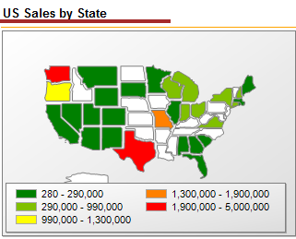

|  |  |
| --- | --- |
| Name: | US Sales by State Chart |
| Type: | Map |
| X Axis | Sum of Total Due |
| Y Axis | State |
| Other: | Map only works for US States |
| Tables: | Person.Address / Person.StateProvince / Sales.SalesOrderHeader |
| Drill-through Report: |  |
| Notes: | N/A |

### Top 10 Sales Reps Chart

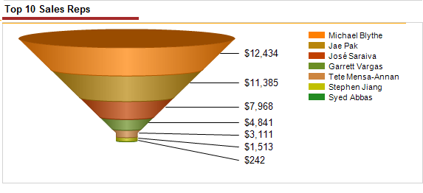

|  |  |
| --- | --- |
| Name: | Top 10 Sales Reps Chart |
| Type: | Funnel |
| X Axis | N/A |
| Y Axis | N/A |
| Other: | N/A |
| Tables: | Sales.vSalesPerson (View) / Sales.SalesOrderHeader |
| Drill-through Report: | Sales by Rep Drilldown |
| Notes: | N/A |

### Sales by Month Drilldown

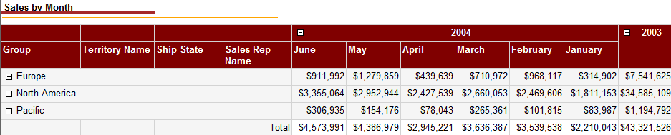

|  |  |
| --- | --- |
| Name: | Sales by Month Drilldown |
| Type: | Drilldown |
| X Axis | Group / TerritoryName / Ship State |
| Y Axis | Year / Month - Month will initially be collapsed with user having the ability to drilldown |
| Other: | Data will be initially collapsed and the user will have the option to drilldown sections |
| Tables: | N/A |
| Drill-through Report: | Person.Address / Person.StateProvince / Sales.SalesOrderHeader / Sales.SalesTerritory / Sales.vSalesPerson (View) |
| Notes: | N/A |

### Sales by Territory Drilldown

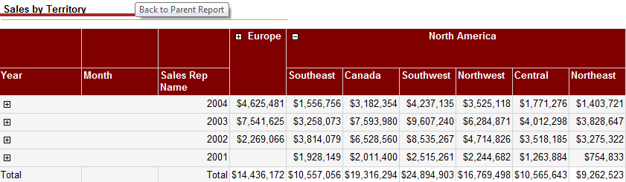

|  |  |
| --- | --- |
| Name: | Sales by Territory Drilldown |
| Type: | Drilldown |
| X Axis | Year / Month / SalesRep Name |
| Y Axis | Territory Group / Territory Name - Territory will initially be collapsed with user having the ability to drilldown |
| Other: | Data will be initially collapsed and the user will have the option to drilldown sections |
| Tables: | Sales.SalesOrderHeader / Sales.SalesTerritory / Sales.vSalesPerson (View) |
| Drill-through Report: | N/A |
| Notes: | N/A |

### Sales by Rep Drilldown

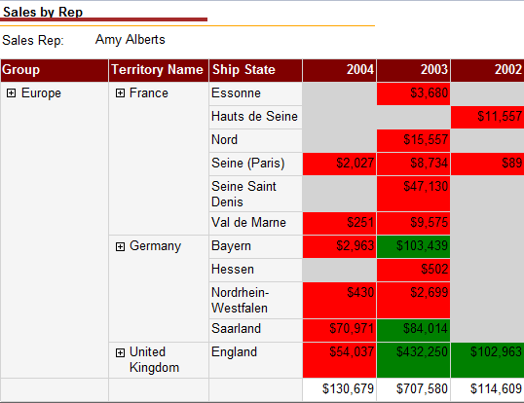

|  |  |
| --- | --- |
| Name: | Sales by Rep Drilldown |
| Type: | Drilldown |
| X Axis | Territory Group / Territory Name / Ship State |
| Y Axis | Order Year |
| Other: | By Default all Groups will be expanded. User will only be able to Select one SalesRep at a time. |
| Tables: | Person.Address / Person.StateProvince / Sales.SalesOrderHeader / Sales.SalesTerritory / Sales.vSalesPerson (View) |
| Conditional Formatting | Conditional Formatting will be applied to the background of the Total Due.  Green: TotalDue > $75,000  Red: TotalDue < $75,000  Yellow: TotalDue = $75,000  Light Grey: TotalDue = $0 |
| Notes: | N/A |